Vuze 360 Degree Camera

Vuze App :

* Vuze Camera app can be downloaded from <https://play.google.com/store/apps/details?id=camera.vuze>

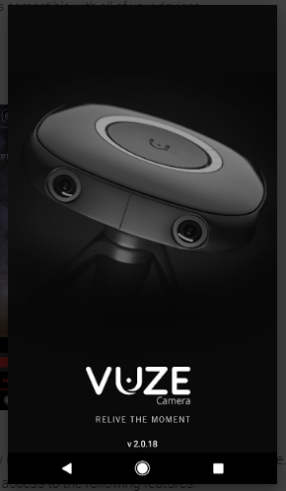

* After downloading the app, connect the app to vuze 360 camera wifi.
* Connect your mobile device to the camera’s WiFi.
* Your camera’s WiFi SSID is its Serial Number, as appears on the bottom of the camera.
* The default password for your WiFi is 12345678.
* The WiFi name and password can be changed through the App’s settings after the first connection. Once connected the blue LED will turn on.
* Operate the camera via the Vuze Camera App.

**Debugging the connection error:**

* If the app is not able to connect to the camera wifi , check the if the camera is using latest firmware version .
* If not, download the latest firmware version .
* Download firmware at <https://vuze.camera/vr-software/#download-firmware>
* Copy the **vuze_fw.bin** file to the SD card root folder and rename the file to **firmware.bin** before proceeding.
* Insert the SD card into the camera’s micro SD slot.
* Disconnect the camera from the computer and turn the camera on.
* The camera will boot normally and will start the upgrade automatically (Orange led starts blinking).
* When Firmware upgrade is complete the camera will reboot and go into standby mode.
* You can check your camera’s firmware version through the Vuze Camera App’s settings.
* In case Firmware upgrade fails Hard Reset will recover the camera (hold down the Power button for 20s).
* Connect to the mobile app and change the bitrate to 120mbps to get the best recording quality.

**Capturing through mobile App:**

* Once the app is connected to the vuze camera, we can start capturing either in video mode or photo mode.

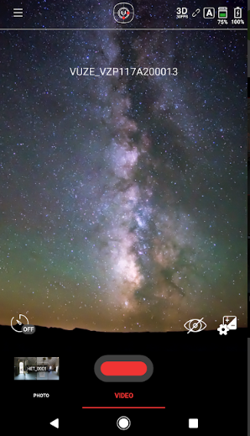

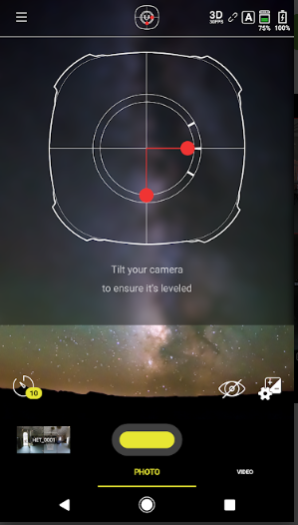

* Captured video and photo is automatically saved in the camera sd card.

**Editing the 360 camera using Humaneyes :**

* Download the Vuze VR studio from <https://vuze.camera/vr-software/>
* After installing the Vuze VR studio, Connect the camera sd to the system where the VR studio is installed.
* Login to the VR studio with credentials:

Email : [ablah.cspace@gmail.com](mailto:ablah.cspace@gmail.com)

Password : aamariwsu

* After logging in, import the video or file that has to be edited in the VR studio.
* You can trim, crop or edit the video using the advanced tools .
* After editing, render the video and export it.

**Injecting the metadata for 360 degree view using Adobe Premiere:**

* Before importing the video into adobe make sure you have rendered the video in VR studio ,if not the video will not be detected as the 360 degree video by adobe premiere.
* Import the video in project panel of adobe and right click it to check if the **VR video** option is available or not.
* If not , we need to interpret the VR video.
* To interpret the VR video , Right-click the clip in the Project Panel and select **Modify** > **Interpret Footage**.
* 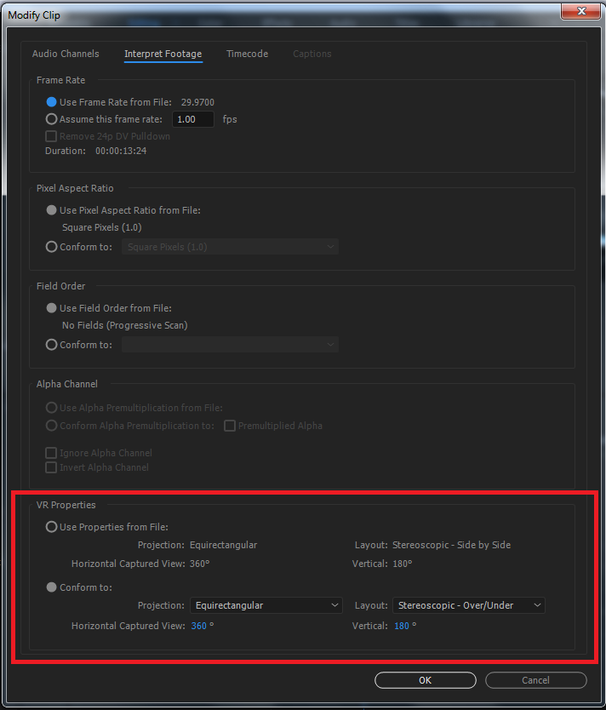
* Make the following changes mentioned in the above image to set the VR properties of the clip. The above changes include certain metadata for 360° playback to be enabled.
* Save the VR settings and export the video.
* We can preview the 360 view of the clip in the adobe.
* For more information on Setting Vr properties visit <https://helpx.adobe.com/premiere-pro/using/VRSupport.html#VRassignments>

**Publishing the VR videos using adobe:**

To publish your VR Video on websites such as YouTube and Facebook:

* Select **Export Settings**>**Video Settings** tab.
* Encode the video using **H.264**, **HEVC**, or **QuickTime**formats.
* Scroll down to check that the **Video is VR** check box and choose the layout which matches your media from the pop-up menu. Based on the metadata that gets added to the encoded video, Premiere Pro recognizes the video as VR Video content for publishers to play back correctly.
* Use the **Stretch to Fill Scaling**setting under **Export Settings**to get the best results for VR video exports.
* Select **Export Settings > Publish** dialog to upload this video directly to websites such as YouTube or Facebook.

**Adding the meta data Without using the Adobe:**

* + Google has recommended to install a 360 video meta data app.
  + Your video file needs to include certain metadata for 360° playback to be enabled
  + Download the latest [360 Video Metadata app](https://github.com/google/spatial-media/releases/latest).
  + Unzip the file, then open the 360 Video Metadata app. If you're on an Apple computer, you may need to right-click the app and click Open.
  + Select the video file.
  + Select both checkboxes and click Save.
  + Enter a name for the file that will be created.
  + Save the file. A new file will be created automatically in the same location as the original file.
  + Upload the new file to YouTube.
  + Wait for the video to process. This may take up to an hour depending on the size of the video.
  + For more information follow <https://support.google.com/youtube/answer/6178631?hl=en&ref_topic=9257783>